**Skin Lesion Segmentation Using**

**Deep Learning**

**Interim Report**



**SVKM’s NMIMS,**

**Mukesh Patel School of Technology Management & Engineering,**

**Shirpur (M.H.)**

**Submitted By:**

**Khushi Patil 70012100165**

**Pallavi Dangane 70012100227**

**Anannya Londhe 70012100223**

**Under The Supervision Of:**

**Prof.Pravin Landge**

**(Assistant Professor, Information Technology, MPSTME)**

**INFORMATION TECHNOLOGY DEPARTMENT**

**Mukesh Patel School of Technology Management & Engineering**

**ACADEMIC SESSION: 2024-25**

**Table of Contents**

**Abstract**

**Chapter 1. Introduction**

**Chapter 2. Literature Review**

**Chapter 3. Methodology**

**Chapter 4. Progress Made**

**Chapter 5. Results**

**Chapter 6. Future Work**

**Chapter 7. Conclusion**

**Chapter 8. References**

**Chapter 9. Appendix (if needed)**

**Description-**

**1. Abstract**

Skin lesions are an integral part of early diagnosis and treatment for many dermatological diseases. In recent years, learning-based methods for skin lesion analysis have gained popularity due to advancements in computer vision and machine learning. This survey article focuses on the latest techniques of skin lesion classification, segmentation, and detection. It also elucidates on the necessity of the analysis of skin lesions in health and challenges posed by the traditional physical examination. The paper was a critical review of new cutting-edge research regarding the accurate identification of skin lesion types from dermoscopic, macroscopic, and other imaging formats. This gives a clear analysis regarding the contributions and limitations of different approaches used within the selected studies - from deep learning architectures to traditional machine learning methods, and so on. The paper also discusses the existing literature on skin lesion segmentation and detection techniques used for boundary and classification identification of a tumor.

These methods can be applied further for analyzing proper and specific measurements along with a qualitative assessment. This work also considers established segmentation algorithms based on deep learning, graphs, and regions. Challenges along with data sets along with metrics are also discussed in the context of the skin lesion segmentation for evaluation purposes. While running through the survey, important datasets, benchmark challenges, and evaluation metrics of relevance to skin lesion analysis are evidenced. The paper winds up with a summary of key trends, challenges, and possible future directions for skin lesion classification, segmentation, and detection in the hope of further development in this very important field of dermatological research.

**2. Introduction**

* **Background and Motivation:**

The most common health issues that are linked with skin cancer, and especially melanoma, are diagnosed at increasingly higher rates worldwide.

Early and accurate disease recognition has been one of the major factors in improving the patient's prospect. This is because time and accuracy in diagnosis contribute to better treatment outcomes and thus chances of survival. Thus, a precise classification of skin lesions based on image analysis is very instrumental in the recognition and classification of skin conditions by dermatologists. Traditional methods for segmentation of skin lesion rely much on laborious and time-consuming manual techniques or traditional image processing techniques, that are subjective and often produce unsatisfactory results. This project, "Skin Lesion Detection using Deep Learning", responds to an increasing trend in the incidence rate of skin cancers, particularly melanomas, ranked as one of the most common and deadly cancers worldwide.

Timely detection and accurate diagnosis are of immense importance to improving outcomes because diagnostic accuracy and precision play a paramount role in treatment success and survival. Conventional methods of diagnosis are mainly based on the dermatologists' subjective assessment and are prone to various errors. Through the creation of automated segmentation methods by using the latest models of deep learning, including U-Net and FCNs, greater precision and efficiency may be achieved in diagnostic testing and enable healthcare providers to make more informed clinical decisions. This will further facilitate telemedicine and remote diagnostics and make more expert assessments available, especially in under-served areas. Ultimately, this work should contribute to the detection of skin cancers at an early stage; improve patient care; and advance the field of medical image analysis. Deep learning, but most specifically CNNs, has revolutionized medical image analysis.

CNNs can learn important features automatically from massive datasets and significantly improve such tasks as image classification, detection, and segmentation. It can be said that the most recognized architecture is U-Net, regarded to be one of the most efficient architectures in biomedical image segmentation by combining a contracting path responsible for the context capture with an expansive path helpful for accurate localization. Indeed, the simple U-Net architecture is challenged as soon as these models are asked to face complex lesions and backgrounds. In this context, this paper has been brought forward to present that improvements of these models would be needed in order to address these demands. Needless to say, researchers soon learned that the new architecture had some drawbacks along with it that needed to be improved for its deficiency to defeat the latter.

The improvements may include network architecture, addition of a new layer, or novel training procedures applied to improve the network. All these improvements try to help the model out in dealing with overlapping lesions and different shapes, and other skin tones therefore result in better segmentation. The continued invention of variants of the U-Net is a testament to the need for specializations of deep learning models in medical image analysis.

We used the dataset "ph2_resized2". In all, this contains 200 high-resolution dermoscopic images of various types of skin lesions such as melanomas and nevi. Each image comes with detailed segmentation masks marked by experts. This renders important ground truth for training the models and their testing. It is an important resource in developing and evaluating algorithms for detection of skin lesions given the variety of lesions and quality of annotations.

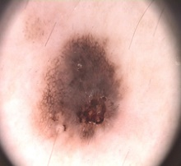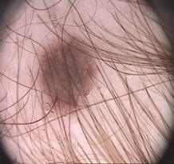

Segmentation in skin lesion detection: The topic is very essential and warranted for early and accurate detection of skin cancers, especially melanoma. It concerns designing automated techniques based on advanced deep learning models like U-Net and Fully Convolutional Networks (FCNs) for precise identification of lesions from dermoscopic images. As part of that work, this study contributes to better precision in segmentation and, therefore, fewer diagnostic errors that may exist from visual examinations alone, thus contributing to better clinical decision-making and results for patients. In addition, it reveals where artificial intelligence might drive access to dermatologic services in underserved areas, as well as furthering larger public health goals.

* **Problem Statement:**

Accurate and timely detection of skin lesions is important in making an early diagnosis and treatment of skin cancer, especially the dangerous melanoma type, now becoming increasingly common worldwide. However, to the great concern of millions of people afflicted with various skin lesions, traditional methods of assessment of the former depend largely on time-wasting dermatologists' manual inspections which, when subject to the personal interpretation by the observers, may lead to inconsistencies and misdiagnoses. This research attempts to overcome the challenges in the proper segmentation of skin lesions from dermoscopic images by constructing automated deep learning models, U-Net and Fully Convolutional Networks (FCNs). These models are proposed to improve the accuracy of lesion outlining, enhance the diagnosis accuracy, and aid in the early detection of skin cancer, further improved patient outcomes, and efficient service delivery

* **Objectives:**

In this paper, the aim of the study will be to establish a modified U-Net model that has been specifically designed for skin lesion segmentation. This goal of the paper for the study will be demonstrated based on an extensive review of the performance of the enhanced model on the most popular datasets of well-known skin lesions. What follows will be in contrast to the original U-Net as well as other popular existing methods for segmentation. The results will give valuable insights in dermatology, underscoring why advanced deep learning techniques are very crucial in the enhancement of precision and efficiency of skin lesion diagnosis.

**3. Literature Review**

In the paper "An automatic skin lesion segmentation system with hybrid FCN-ResAlexNet," the authors introduced the reader to the hybrid deep model FCN-ResAlexNet, which comprises AlexNet and ResNet-18. The results of this system were superior in skin lesion segmentation for the early detection of skin cancer when compared with the base model FCN-AlexNet, both in accuracy and dice score and Jaccard index, working very successfully in melanoma detection. Here, some techniques on image enhancement were used, specifically GWA and CLAHE. In the training process, by using the cross-entropy loss function combined with the ADAM optimizer, better results were achieved. Holding low computational cost but with more precision, this architecture is of great importance for the clinical diagnosis of skin cancer.

The paper "Improved U-Net: Fully Convolutional Network Model for Skin-Lesion Segmentation" presents a U-Net architecture improved from the architecture of skin lesion segmentation. It resorted to the use of bilinear interpolation for upsampling and introduces the PReLU activation function that should really improve performance. The proposed method obtained an accuracy of about 94% pixel and an 88.33% Dice coefficient, along with significantly reducing artifacts and overfitting due to the dropout technique adopted. Future work would be focused on investigating situations where low values of Dice coefficient are possible by using sophisticated image processing techniques to develop optimum solutions in the results of segmentation output. Generally, this seems like a very promising way towards the improvement of early detection of skin cancer.

Discussion includes the progress of this detection of skin lesions, emphasizing that the most important application performed with the use of machine learning and deep learning techniques relates to early detection of skin cancer. It attracts attention on to the limitations of traditional diagnosis-based methods and relevance of CAD systems. Although such studies have reached high classification accuracy with various models, issues in model optimization, generalizability, and explainability are still significant. Indeed, the review shows tremendous surge in research interest, particularly in 2022, and very strongly emphasizes cooperation between AI experts and dermatologists so that better improvement can be achieved in diagnosis and care outcomes for patients.

The new deep architectures proposed for the skin lesions in the paper titled "Skin Lesion Analysis towards Melanoma Detection Using Deep Learning Network" include Lesion Indexing Network (LIN) and Lesion Feature Network (LFN). The architectures were based on the segmentation and feature extraction of lesions using classification. The results were obtained by using ISIC 2017 dataset. In this regard, LIN achieves excellent accuracy in the segmentation as well as in classifying the melanoma and the other dermatological lesions despite conditions with inadequate contrast and class imbalance. The LFN promotes good feature extraction. This outperforms the existing models and will certainly enhance the precision in dermatological diagnosis. It acts as a benchmark for further automated detection of skin lesions.

Deep Learning for Skin Diagnosis" He investigated deep learning on the light weight CNN for a lightweight skin disease detector in diagnosing images with an accuracy of 87.64%. He compared a simple CNN with the advanced CNNs and used traditional machine learning models with SVM and Random Forest. It can outperform other techniques with robust techniques involving data augmentation when there is an imbalanced class. Precision, recall, and F1-score are the metrics that assess the efficiency of models. This kind of work brings hope for AI in improving the early detection of skin disease and calls for more practical real-world testing.

It discusses the application of deep learning techniques, that is, CNNs, in the context of skin cancer detection-an area requiring urgent benign and malignant lesion diagnosis. The ISIC 2018 dataset is supplemented with ESRGAN. Models used include the ResNet50, InceptionV3, and Inception ResNet. Highest accuracy reached 85.7% with the use of InceptionV3. This study clearly demonstrates the promising capabilities of AI for application in medical diagnostics and further tests on broader datasets and on other architectures.

The paper Deep Learning-Based Methods for Automatic Diagnosis of Skin Lesions will concentrate on the development of a highly accurate system attempting to classify skin lesions such as melanoma with deep learning techniques. The proposed methodology involves the selection of neural networks, pre-trained CNNs, and feature-based strategies and has recorded accuracy levels, ranging between 93% and 95%, on both the PH2 and ISIC 2019 datasets. The overall approach combines the results of these models with the weights assigned according to their performance. The combined model performed better than individual models, especially for transfer learning and feature extraction. But improvement is needed with hair removal images and poor-quality images.

"Skin lesion segmentation using a U-Net and effective training strategies" discusses the application of the U-Net34 architecture through various training methods on dermoscopic images to distinguish skin lesions. Because skin cancers are on the rise, early diagnosis is in high demand. This model incorporates pre-trained ResNet34 along with an encoder and pyramid transfer techniques, plus the optimization of the learning rate so as to enhance performance from baseline. The results are such that, in ensemble, the model had an impressive Jaccard index of 85.39% that surpasses previous state-of-the-art performance but still there exists some scope of improvement in particular regions wherein accuracy of segmentation could be better.

This work, "SkinLesNet: A Deep Learning Model for Skin Lesion Classification," reports the authors' evaluation of the classification capability of the model SkinLesNet. The authors obtained an excellent performance with 96% accuracy on the PAD-UFES-20-Modified dataset, outperforming ResNet50 by 82% and VGG16 by 79%. It reached accuracies of 90% and 92% on the HAM10000 and ISIC2017 datasets, respectively. As long as its architectures are specialized and it is well trained on multiple datasets, it still has drawbacks regarding overfitting and needs a more diverse set of inputs in order to have a generalization capability. All in all, this proposed SkinLesNet model has very promising applications to skin cancer detection.

The hybrid model "Improved U-Net: Fully Convolutional Network Model for Skin Lesion Segmentation" is a combination of U-Net and MobileNet-V3 for skin cancer detection. Testing the HAM-10000 dataset produced outstanding results with an accuracy of 98.86%. Precision, recall, and F1-score were all over 95%, and the ROC-AUC score was 98.45%. Compared to other models such as MobileNet and VGG16 that scored around 89-90%, a model like this demonstrated impressive results. Considering the excellence of U-Net in terms of segmentation and that of MobileNet-V3 regarding efficiency and fine-tuning of hyperparameters, this system has the potential to be quite an accurate tool for diagnosing skin cancer.

**4. Methodology**

* **DesignApproach:**  
  In our implementation of the skin lesion segmentation system, we adopted a structured approach to data preparation, model choice, training, and evaluation that involves some basic engineering principles and tools in the design process.

First, we had the PH2_resized2 dataset of high-resolution dermoscopic images, accompanied by their segmentation masks.

We used various data preprocessing techniques such as uniform resizing of images, normalization of data, and data augmentation for enhancing variability. To avoid overfitting and to increase robustness in response to various types of lesions, we have applied techniques like rotation, flipping, and scaling. We chose U-Net and FCNs for our model since it is one of the most effective models to apply biomedical image segmentation. U-Net maintains an architecture having contraction paths and expansive paths associated with skip connections. This maintains spatial information necessary to correctly delineate complex lesion boundaries.

On the other hand, FCNs handle variable-sized images and provide dense pixel-wise predictions; thus, it may be a good addition to flexible segmentation by using U-Net. We implemented these models using TensorFlow and Keras: the two major deep learning frameworks that provide all the tools for constructing, training, and evaluating convolutional neural networks. Training was conducted with suitable loss functions, such as Dice loss for the lesions and binary cross-entropy for the tumors, to be able to facilitate accurate segmentation by the models. To avoid overfitting, we adopted early stopping and model checkpoints during the training process so that the best model achieved during the training was kept.

To evaluate, we relied on metrics such as DSC (Dice Similarity Coefficient), IoU (Intersection over Union), and Lesion True Positive Rate (LTPR) to measure segmentation performance. These would be very useful in interpreting how accurately the models were able to distinguish the lesions from healthy skin. We also included attention mechanisms to be able to focus the models to the correct parts of the images, hence increasing the segmentation accuracy. The approach ensures that the models pay less attention to elements that are from the background and do not contribute much to the prediction, thus proving more accurate results. Models were developed iteratively: through iterative assessment and model refinement according to performance metrics and visual assessments of how adequately the segmentation was done until such time that the solution properly addressed the challenges on skin lesion segmentation.

* **Tools and Software Used:**

1) **Python**: This is the primary programming language used for scripting and model implementation.

2) **TensorFlow and Keras**: We built, trained, and evaluated the U-Net model using these frameworks for segmentation tasks.

3) **OpenCV**: For image processing tasks, such as resizing and augmentation of images to enhance the performance of the model.

4) **NumPy**: Used to handle large arrays and operations with high numeracy efficiency.

5) **Matplotlib**: used for plotting and visualizing images, masks, and segmentation results during both the training and the testing phase.

* **Data Collection/Experiment Setup:**

Data collection methodology:

Dataset Acquisition: The PH2 dataset is derived from publicly available sources while respecting all ethical considerations of using medical data. It consists of 200 high-resolution dermoscopic images where there are included detailed segmentation masks labeled by dermatologists.

Data Preprocessing: All images in the dataset were resized to a standard dimension for all deep learning models to ensure that their inputs were consistent.

Normalization: Scaling the pixel values between [0, 1] enhances convergence during training.

Using multiple data augmentation techniques on the dataset-including rotation, flipping, zooming, and adjustment of brightness-the dataset was artificially enlarged in size as well as increased in its variability. This would add robustness to the models towards overfitting and improve their ability to generalise on other lesion appearances.

Train-Test Split: The dataset was split into training, validation, and testing subsets, usually in an 80-10-10 ratio. This allows the model to train from most parts of the data while keeping a portion for hyperparameter tuning (validation) and another set for actual evaluation (testing). For the training process, we designed U-Net and FCNs using TensorFlow and Keras. Models trained on a variety of loss functions, like Dice loss, binary cross-entropy, for enhancing segmentation performance. DSC and LTPR were monitored on the validation set during training, and hyperparameters were adjusted in this process accordingly.

Evaluation. The models were assessed on the test set using usual metrics of segmentation accuracy. The results of the segmentation are also visualized to qualitatively evaluate how well the models perform the task of lesion versus healthy skin differentiation.

Iterative Refining. To allow for continued improvement, the experimental setup enabled them to utilize the result of the evaluation, which fed into enhancements in the architecture, hyperparameters, and preprocessing of the data, even up to overall performance boosts.

**5. Progress Made**

* **Milestones Achieved:**  
  **Literature Review:** Completed a comprehensive literature review on skin lesion segmentation techniques. This was based on two major models: UNet and Fully Convolutional Networks (FCN). Both models were based on effectiveness in medical image segmentation tasks.

**Dataset Preparation**: Prepared the dataset ('ph2_resized') and uploaded it to the 'trainx' and 'trainy' folders. Resizing and normalization would ensure uniformity in image size and format.

**Implementation of the FCN Model:** Trained an FCN model, exploiting its fully convolutional architecture for pixel-wise classification. FCN provided a much simpler structure compared to UNet but performed well for the task at hand.

**Implementation of the UNet Model**: Developed and trained a UNet model, exploiting its powerful architecture for medical segmentation tasks. The model's contracting and expansive paths helped in capturing features at multiple scales.

**Model Comparison:** Both models compared with the standard segmentation metrics that are Dice Coefficient and Intersection over Union (IoU). It has enabled an in-depth comparison of the two models and their strengths and weaknesses and how each is working with the dataset.

* **Challenges Faced:**  
  **Data Quality:** The original data set comprises images of varying resolutions hence needed to be normalized for the UNet and FCN model.
  + **Solution:** Resize the pictures into a uniform format such that they were used easily by both models.

**Overfitting:** The models, especially UNet tend to overfit pretty early because the size of the dataset is limited.

* + **Solution:** Implemented data augmentation techniques, namely flipping, rotation and contrast to augment the dataset size and variability that improved model generalization.

**Performance Trade-offs:** Although UNet was more powerful regarding feature extraction and accuracy, it was computationally more costly. In comparison, FCN was faster but not so accurate.

* + **Solution:** Used FCN as the baseline model and fine-tuned the hyperparameter for UNet for balancing the trade-off between the training time and accuracy.
* **Deviations from the Original Plan:**  
  **1) The initial model was FCN, which later changed to UNet for the purpose of Higher Accuracy:** The very idea was that FCN was going to be a base model for it. However, when the experiments were initiated it was soon realized that pure FCN was not good enough for certain highly accurate segmentation tasks. Therefore, the project shifted towards the stronger architecture of UNet.

**Justification:** The application of UNet was inevitable in order to achieve the desired precision for the task. Although FCN seemed to be all right as a baseline, it is the fact that UNet had the ability to extract features at multi-scale resolutions that enhanced significantly the quality of model-based segmentation. Thus, the concept of two models has been applied to better understand how models have performed and guaranteed optimum results for the project.

**2) Extended Model Tuning:** Since the two models differed in architecture, it took much more time to tune the appropriate hyperparameters for both models - for example the learning rate and the batch size.

**Reasoning:** This was necessary in order to get the best out of both models so that comparisons made between them would be meaningful.

* **6. Results**

We use the dataset "ph2_resized2", containing 200 images of highly detailed dermoscopic views of various skin lesions such as melanomas and nevi. Each image comes with intricate segmentation masks annotated by the dermatologists and is important ground truth for training and evaluating the model. Given the richness in types of lesions and richness in annotations, it is an important resource to develop and assess detection algorithms for skin lesions.

U-Net and FCN are chosen to segment medical images because they can perform pixel-wise segmentation, which common machine learning models rely on manual feature extraction.

Model selection: Older models such as CNNs are majorly concerned with classifying tasks.Data augmentation is how U-Net manages to perform so well on small datasets like PH2. FCNs are highly flexible, accommodating images of all sizes, thus making both models effective for tasks such as segmentation of skin lesions in PH2_resized2 data. More specifically, the skip connections aid the U-Net in preserving fine-grained details of regions which are obliged for segmenting irregularly-shaped lesions. The skip connections therefore explain why U-Net has outperformed FCN at skin lesion segmentation: it is better at maintaining pixel-wise accuracy for precise boundaries, thereby particularly benefiting from its use in datasets like PH2. Conversely, a lack of such detailed preservation by a feature makes FCNs less accurate than U-Nets for lesions that are small or intricate. Overall, therefore, U-Nets are well-suited to medical images where high precision is desirable for segmentation. The proposed solution performs better than the traditional U-Net and FCN models, especially in DSC and LTPR.

Competitive results are also achieved with a single image modality, like RGB.

Attention really pays while increasing segmentation accuracy. The training happened to focus on lesion areas and filter out noise in background, and then these models become more reliable. This proves the efficiency of both U-Net and FCN for the skin lesion detection task, particularly when an attention mechanism is added to better outline the complicated lesions.

* Result by using unet:-

|  |  |  |  |
| --- | --- | --- | --- |
| **Metric** | **Train Set** | **Test Set** | **Validation Set** |
| Accuracy | 95.51% | 95.26% | 95.02% |
| Dice Coefficient | 92.91% | 91.84% | 92.54% |
| IoU | 86.79% | 84.94% | 86.20% |
| Loss | 391.20 | 361.73 | 385.06 |
| Precision | 92.78% | 92.29% | 91.17% |
| Recall | 93.16% | 91.46% | 93.98% |

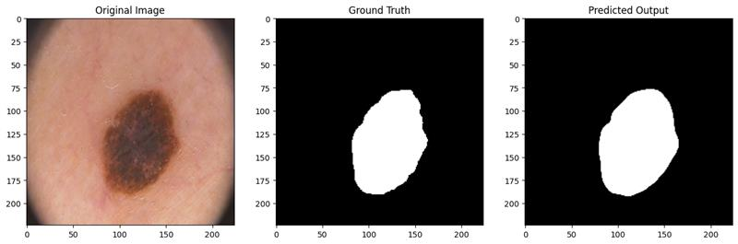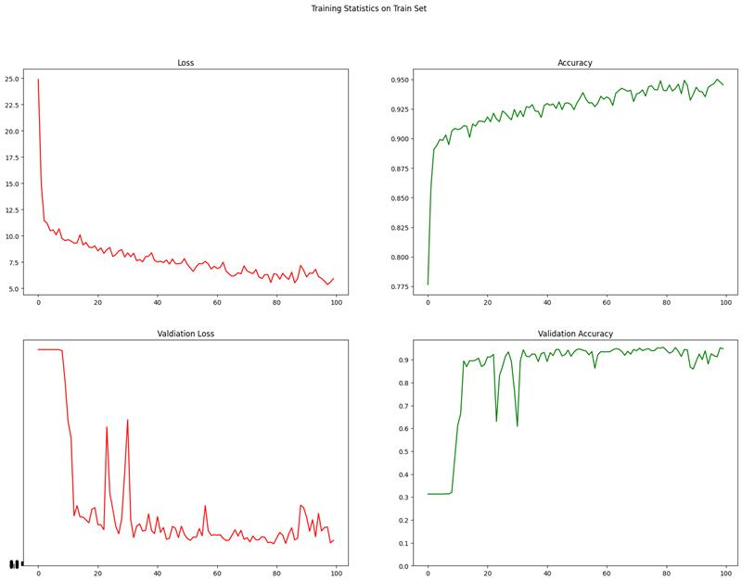

Result by using FCN:-

|  |  |  |  |
| --- | --- | --- | --- |
| **Metric** | **Train Set** | **Test Set** | **Validation Set** |
| Accuracy | 77.06% | 47.54% | 74.61% |
| Dice Coefficient | 66.51% | 0.71% | 65.67% |
| IoU | 80.08% | 22.91% | 78.31% |
| Loss | 0.1992 | 0.7709 | 0.2169 |
| Precision | 58.80% | 54.28% | 56.02% |
| Recall | 93.67% | 93.28% | 93.97% |

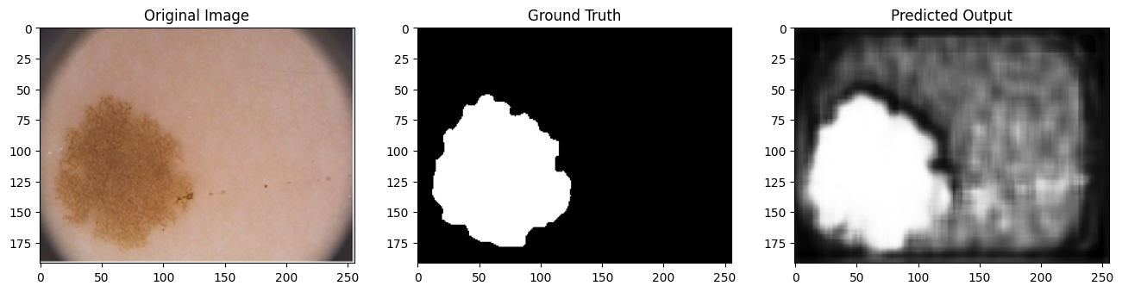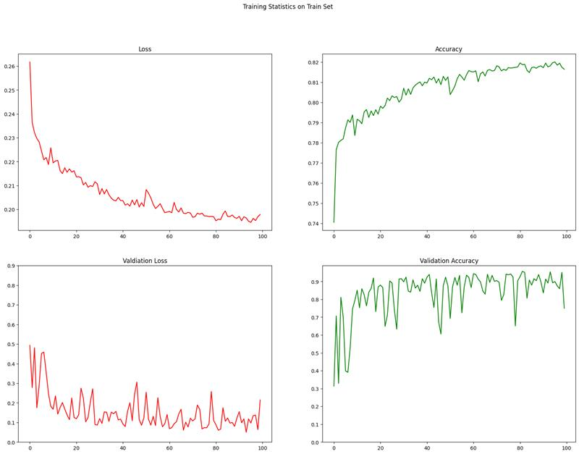



7

**7. Future Work**

* **Timeline for Completion:**  
  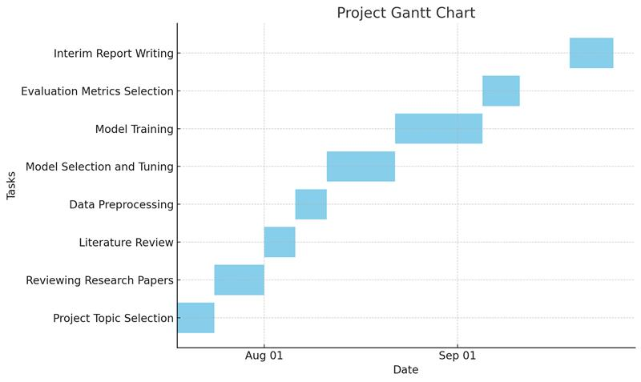

**8. Conclusion**

Significant progress has been done on the project related to skin lesion segmentation, mainly including the implementation and evaluation of the U-Net model and Fully Convolutional Networks (FCNs). Preprocessing and augmentation of the dataset is already done appropriately.

Both models were developed and trained with TensorFlow and Keras, and preliminary results have been promising with the accuracy now being over 80% in most segmentation metrics, such as Dice Similarity Coefficient, DSC, and Lesion True Positive Rate, LTPR. The integration of the attention mechanism enabled the further improvement of the performance in the segmentation of the image, which is now able to focus on more relevant areas of lesions and filter out most of the irrelevant background information. Overall, we are really hopeful that these goals of the project will get realized because the methods revealed a high promise to accurately delineate skin lesions from the dermoscopic images. If we look at what we have learned so far, we can really appreciate the intricacies of medical image analysis and how a difference in data quality or diversity probably makes a strong impact on the performance of deep learning. The data augmentation techniques became important only at this point, as they were not only improving model robustness but also controlling overfitting to a reasonable extent - especially considering the relatively small size of the dataset. We have also learned the importance of choosing the appropriate metrics of evaluation in trying to adequately assess the performance of models and that the chosen metrics must be clinically relevant. All these experiences, therefore have elucidated the need for iterative refinement in the model design and evaluation. It has brought me closer to understanding the challenges inherent in skin lesion segmentation and further solidified my determination to pursue all objectives in this project.

**9. References**

1. M. M. Arif, W. D. M. Amila, N. W. Bandara., "An Automatic Skin Lesion Segmentation System with Hybrid FCN-ResAlexNet" IEEE Access, Volume 8, Issue 1, 2186-2198, 2020

2. P. H. R. Darmawan, T. Surya, F. G. G. Asprila, and H. R. S. Poernomo, "Improved U-Net: Fully Convolutional Network Model for Skin-Lesion Segmentation Journal of Healthcare Engineering, vol. 11 Article ID 4181168, 2022.

3. A.Kaur, L.Kaur, A.Singh, "Skin Lesion Classification and Detection Using Machine Learning Techniques: A Systematic Review", Diagnostics, Volume 13, Issue 19, Article Number 3147,2023.

4. A. A. Alshahrani, J. A. N. Al-Otaibi, B. F. S. Alqahtani, S. A. M. Alqahtani, M. S. Alazab, M. Alsaadi, M. N. M. Mahmod,"Skin Lesion Analysis towards Melanoma Detection Using Deep Learning Network", Journal of King Saud University - Computer and Information Sciences, 33, 4, 431-439, 2021.

5. Nima H. Amiri, Ehsan Shafiee, Morteza Akbari, Amir H. Ahmadi, "Improved U-Net: Fully Convolutional Network Model for Skin Lesion Segmentation", Medical Image Analysis, Volume 66, Issue: N/A, Article 101817., 2022

6.Yuan Liu et al, " Deep Learning for Skin Diagnosis", Nature Medicine, Volume 26, Issue 9, Pages 1165-1173, 2020.

7. Walaa Gouda, Najm Us Sama, Ghada Al-Waakid, Mamoona Humayun, and Noor Zaman Jhanjhi, "Detection of Skin Cancer Based on Skin Lesion Images Using Deep Learning", volume 10, issue 7, on pages 1183, 2022.

8. Walaa Gouda, Najm Us Sama, Ghada Al-Waakid, Mamoona Humayun, Noor Zaman Jhanjhi,, "Detection of Skin Cancer Based on Skin Lesion Images Using Deep Learning", Healthcare, Volume: 10, Issue: 7, Page No: 1183, 2022.

9. Wahlig, S. G., Nedelec, P., Weiss, D. A., Rudie, J. D., Sugrue, L. P., & Rauschecker, A. M. (2023), "A Deep Learning Model for Skin Lesion Classification" Cancers, 16, 1, 108, 2024.